**DBMS ASSIGNMENT**

Name: ANIK DUTTA

Enrollment Number: 2011200001007

Registration Number:  20001001868

________________________________________________________

**1. Create and insert given data in table customer.**

create table customer (cust_id int ,

cust_fname varchar2(100) ,

cust_lname varchar2(100) ,

territory varchar2 (100) ,

cred_lmt int ,

mngr_id int ,

marital_status varchar2(100) ,

sex varchar2(30) ,

income int );

insert into customer(cust_id , cust_fname , cust_lname , territory , cred_lmt , mngr_id , marital_status , sex , income) values

(01, 'Rahul','Singh','India', 10000 , 112 , 'Single' , 'Male' , 65000);

(02, 'Meg','Sen','India', 15000 , 113 , 'Married' , 'Male' , 67000);

(03, 'George','Matthew','Italy', 12000 , 114 , 'Single' , 'Male' , 63000);

(04, 'Jennifer','Lopez','America', 14000 , 115 , 'Married' , 'Female' , 68000);

(05, 'Robert','Jhonson','Australia', 15000 , 116 , 'Married' , 'Male' , 65000);

(06, 'Meghna','Chakraborty','India', 15000 , 117 , 'Married' , 'Female' , 65000);

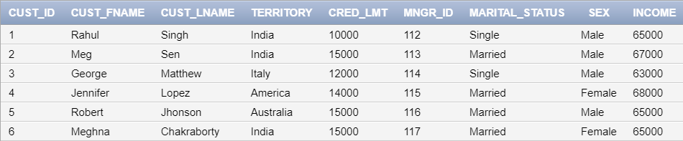

**2. Alter table and Add column stay_from_year**

alter table add stay_from_year int ;

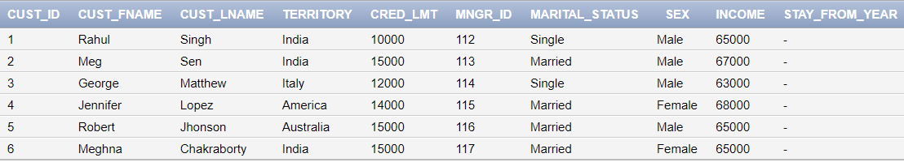

**3. Set value of stay_from_year as 2001 for Italy/America and 2003 otherwise**

update customer

set stay_from_year = 2001

where territory in ('Italy' , 'America');

update customer

set stay_from_year = 2003

where territory not in ('Italy' , 'America');

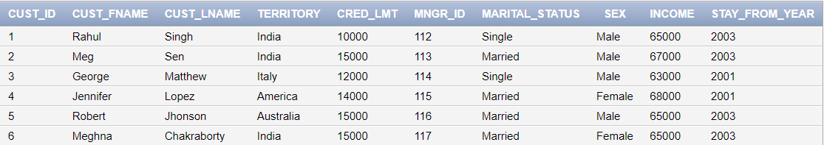

**4. Display credit limit attribute for America**

select cred_lmt from customer

where territory in ('America');

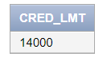

**5. Delete the record corresponding to Meg Sen**

delete from customer

where cust_fname = 'Meg' and cust_lname = 'Sen' ;

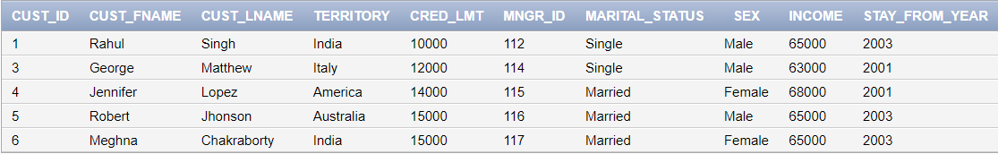

**6.Show all attributes for Italy// Show all data in the territory Italy**

select * from customer

where territory in ('Italy');



**7. If territory is India and status is Single set value of credit to 7000**

update customer

set cred_lmt = 7000

where territory in ('India') and marital_status = 'Single' ;

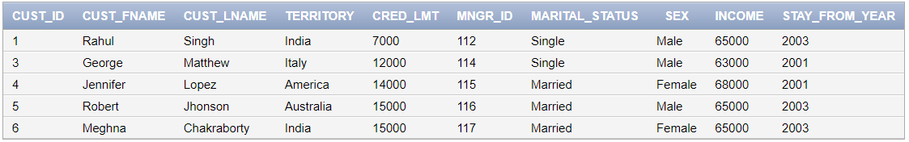

**8. Rename cust_fname to first_name**

alter table customer

rename column "CUST_FNAME" to "first_name";

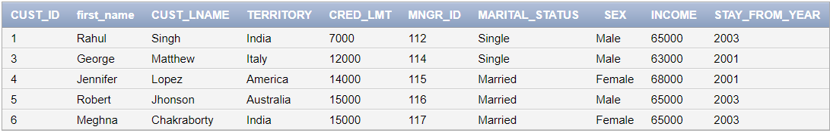

**9. Rename cust_lname to last_name**

alter table customer

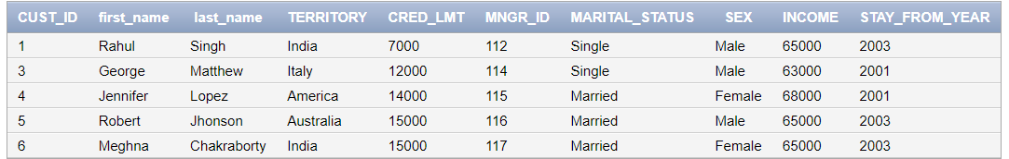rename column "CUST_LNAME" to "last_name";

**10. Create table cust1 from the old table customer(copy structure as well as data using CTAS statement).**

create table cust1 as

select *from customer;

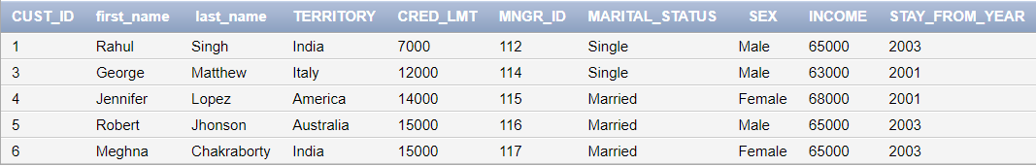

**11. Create tables cust2 without values of cust1 using CTAS statement.**

create table cust2 as

select *from customer where 1=2;

**12. Create tables cust3 with attributes cust_id,cust_fname,cust_lname,income from old customer table only 5 rows.(using CTAS statement).**

create table cust3 as (select cust_id, first_name, last_name, income from customer where cust_id<=5);

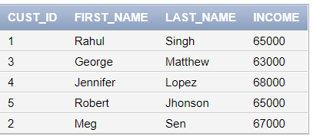

**13.Create tables cust4 with attributes name customer_id,firstname,lastname, income from old customer table(using CTAS statement).**

create table cust4 as (select cust_id, first_name, last_name, income from customer);

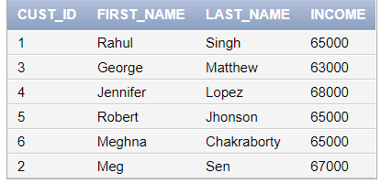

**14. Drop column income from cust1.**

alter table cust1 drop column income;

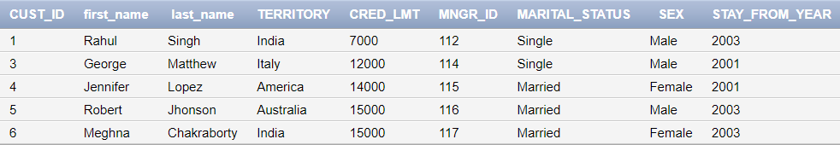

**15. Rename table cust1 to cust_one**

alter table cust1 rename to cust_one;

**16. Insert values into cust2 table from customer table**

insert into cust2

select * from customer;

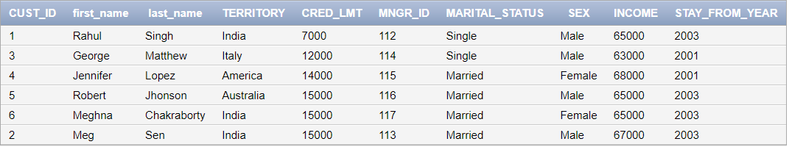

**17. Insert values into cust3 table with attributescust_ id, f_name, l_name,Income from customer table where income > 50000**

insert into cust3 (select cust_id, first_name, last_name, income from customer where income>50000);



**18. alter the table cust4 change cust id to varchar(6) and income to number(5)**

alter table cust4 modify cust_id varchar(6);

alter table cust4 modify income number(5);

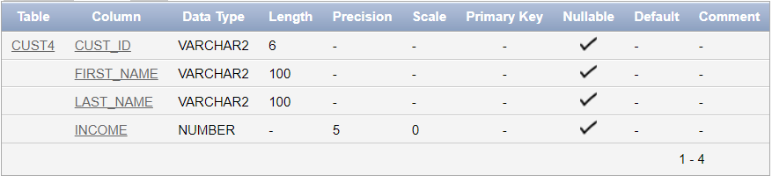

**19.Add new attribute mngr_name to cust4 and insert 5 records**

alter table cust4 add mngr_name varchar2(100);

insert into cust4 (mngr_name) values ('Harry');

insert into cust4 (mngr_name) values ('James');

insert into cust4 (mngr_name) values ('Pushpa');

insert into cust4 (mngr_name) values ('Shiva');

insert into cust4 (mngr_name) values ('Ram');

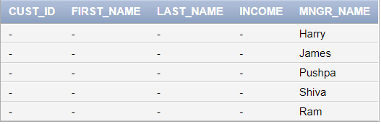

**20. Add attribute territory to cust4**

alter table cust4 add territory varchar2(100);

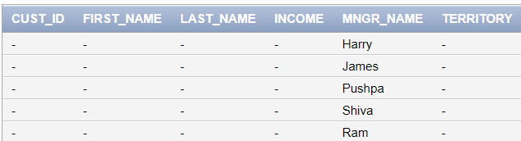

**21. Drop table cust3 and then bring it back.**

drop table cust3;

flashback table cust3 to before drop;

**22. Increase the size of the column custid by 5.**

alter table cust3 modify cust_id varchar(105);

**Old column custid size =100**

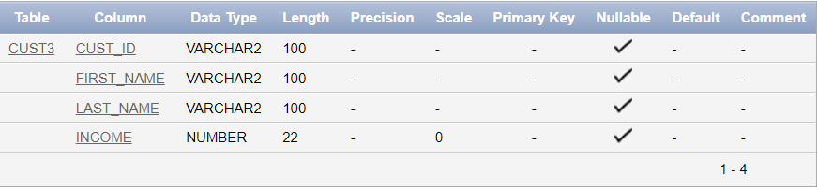

**New column custid size =105**

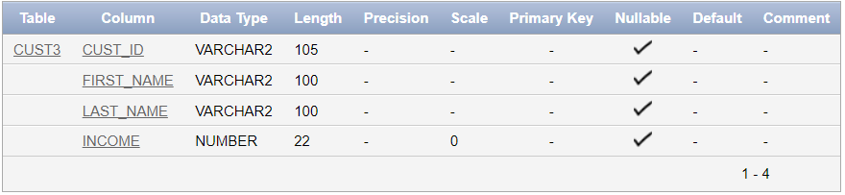

23. **Suppose the customer with id no C63 has changed her last name & now it is just same as the customer with id no C68.**

SELECT last_name, COUNT(last_name)

FROM cust3

GROUP BY last_name

HAVING COUNT(last_name) > 1

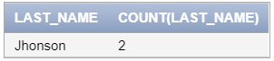

**24. Update customer set lname=(select lname from customer where cid=C63) where cid=C68.**

update customer set last_name = (select last_name from customer where cust_id =5)

where cust_id =1;

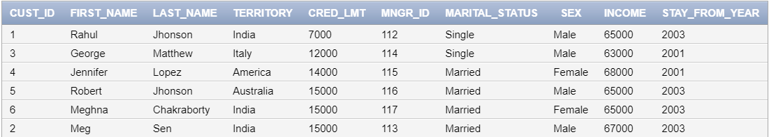

**25. Display the records where territory=America & crd_lmt=25000.**



**26. Display the records of all Indian customers whose income>20000.**

select * from customer where territory='India' and income>20000;

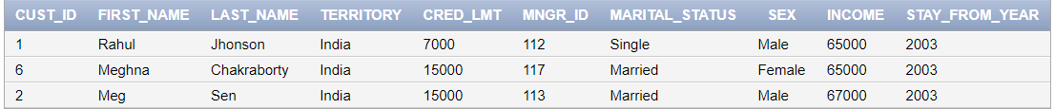

**27.** **Display the name of the customer having crd_lmt between 2000 and 7000.**

select * from customer where cred_lmt between 2000 and 7000;



**28. Display the records of the customers having income 20000,24000,300,4500 using only one query.**

select * from customer

where income in (20000,24000,300,4500);



**29. Display the records in ascending order of first name**

select * from customer order by first_name ;

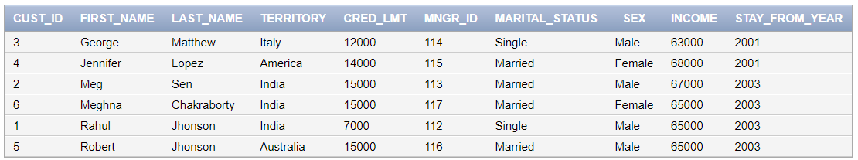

**30. Display the records in descending order of income**

select * from customer order by income desc ;

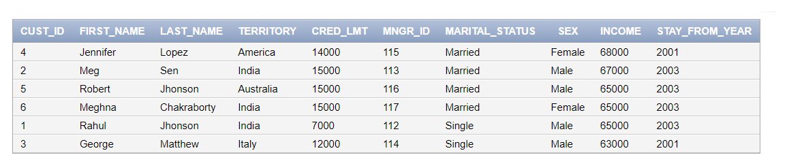

**31. Insert a duplicate record and display all the records.**

insert into customer(cust_id , first_name , last_name , territory , cred_lmt , mngr_id , marital_status , sex , income) values

(01, 'Rahul','Singh','India', 10000 , 112 , 'Single' , 'Male' , 65000);

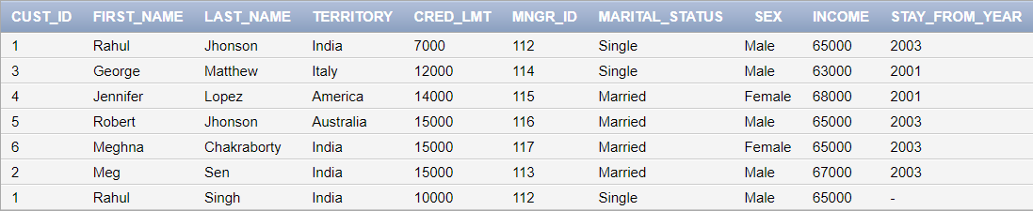

**32. Suppose your friend wants to select a name from the names of the customers. Show the different names of the student.**

select distinct first_name, last_name from customer;

